

SS25 HIT 137 SOFTWARE NOW

ASSIGNMENT 3
GROUP: SYD 16

GROUP MEMBERS:

- APURBA PAUDEL- s398926
- RAKSHA TIMILSINA- s398446
- SUBEK SHARMA- s398321
- SUJAN SIGDEL- s399205

TABLE OF CONTENTS

1. AI DECLARATION 2
2. INTRODUCTION 2
3. APPLICATION OVERVIEW 2
4. OBJECT ORIENTED DESIGN 6
5. IMAGE PROCESSING FEATURES 8
6. GRAPHICAL USER INTERFACE DESIGN 10
7. TEAM COLLABORATION 13
8. INDIVIDUAL CONTRIBUTIONS 14
9. CONCLUSION 15
10. REFERENCES 15

- AI DECLARATION
This assignment is the collective effort and learning of all the group members. All coding and documentation tasks were completed by the group members. AI tools were minimally used in order to understand general programming concepts and help with identifying bugs.

- INTRODUCTION
This assignment mainly focuses on the development of a desktop based image editing application utilising Python. The main aim of the assignment was to demonstrate the understanding of Object-Oriented Programming (OOP), graphical user interface (GUI), and image processing techniques. Major features include interactive interface, the app lets users upload pictures, make different visual changes, and save the results.

This image editor supports various image processing operations such as grayscale conversion, edge detection, Gaussian blurring, brightness and contrast modification, image rotation, flipping, and resizing. The OpenCV library is used to carry out these processes, and Tkinter, which is the standard GUI toolkit for Python, is utilized in order to create the graphical user interface [1], [2]. GitHub was utilized for version control and contribution tracking in this project[5].

- APPLICATION OVERVIEW
The application consists of three major parts: The GUI, the image processing module and the application controller. This structure makes it easier to keep track of responsibilities and makes it easier to maintain.

Users can open image files in formats such as JPG, PNG and BMP. When the image is uploaded, it is displayed in the main window. It can be changed using buttons and sliders in the control panel. The transformed image can then be saved by either replacing the original file or using the ‘Save As’ option. This design thus meets the functional requirements while also being easy to use and understand.

Grayscale:

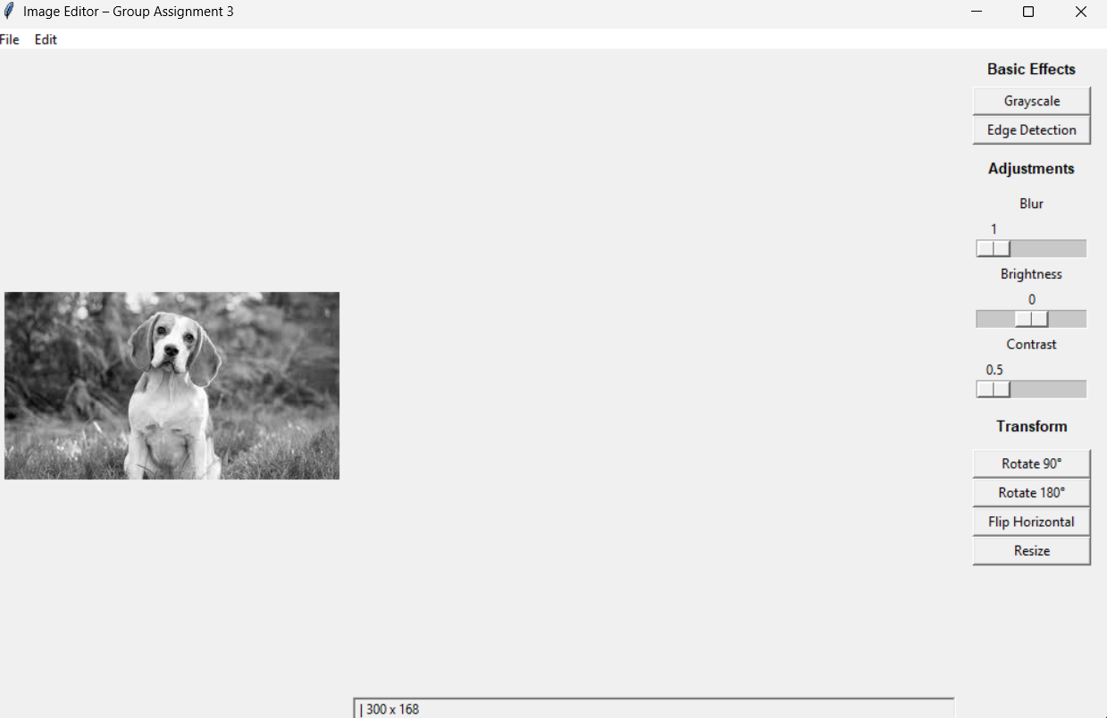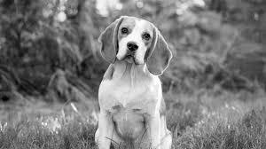

Edge detection:

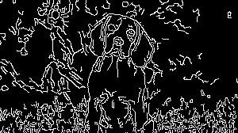

Blur:

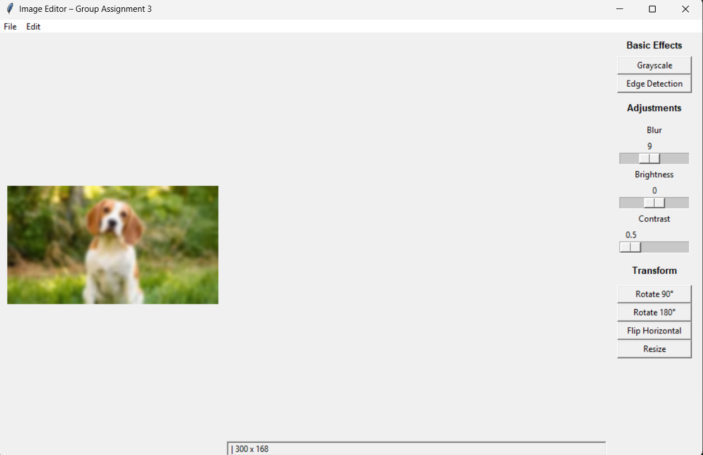
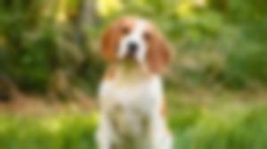

Rotation:

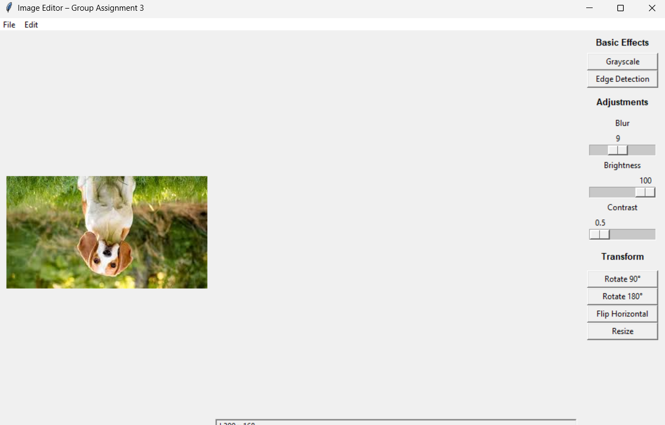

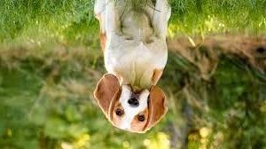

- OBJECT ORIENTED DESIGN
The application shows how OOP works by using three primary classes: ImageProcessor, ImageEditorGUI, and AppController. All the code that changes the images, such as filtering, transforming and adjusting are contained in the ImageProcessor class. The ImageEditorGUI class is responsible for the user interface, which includes buttons, sliders , displaying images and showing status information.

The image processor is connected with the GUI through the AppController. It is responsible for user activities, calls the right processing functions and changes the interface as needed. This interaction between classes shows how to integrate encapsulation, constructors, methods and class communication well, which are the basics of OOP [3].

Code snippet:
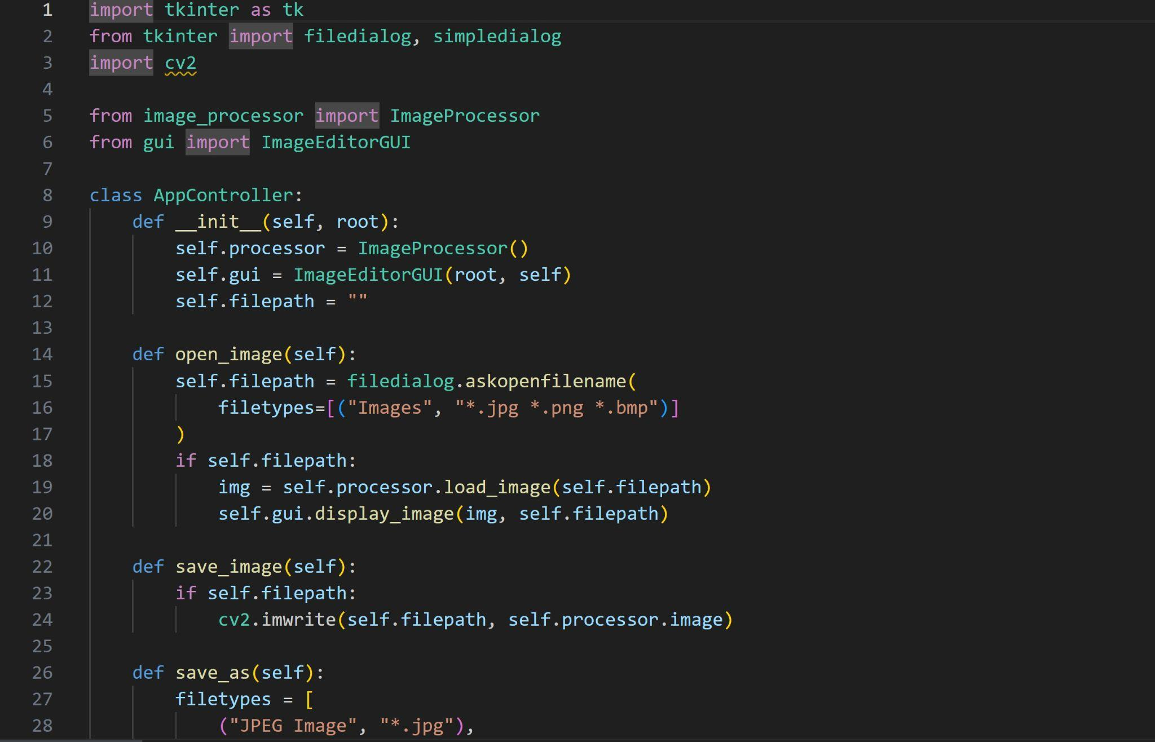
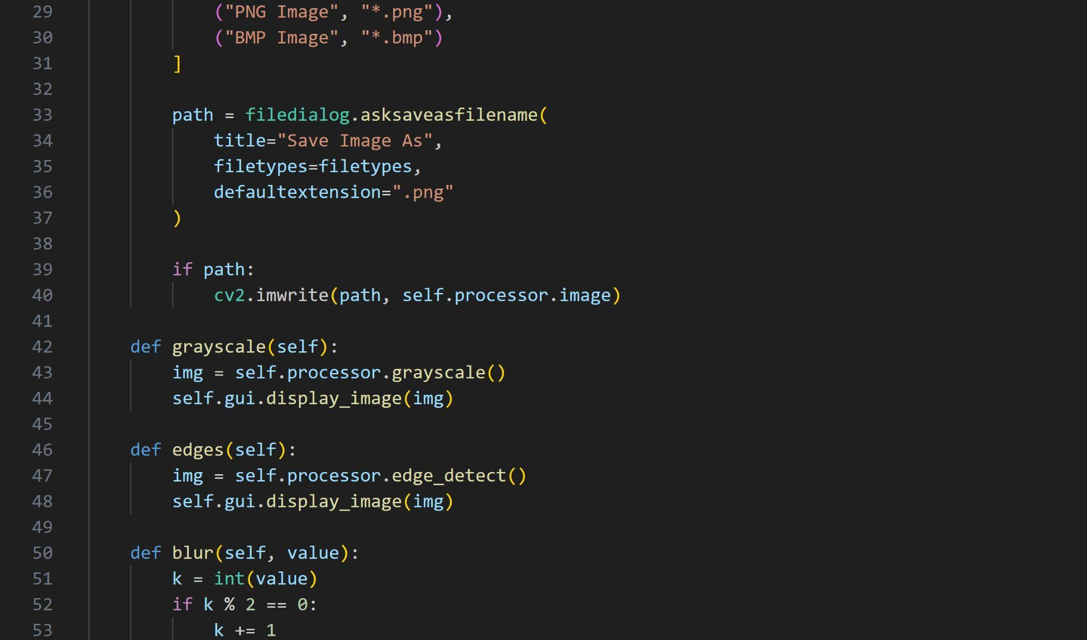
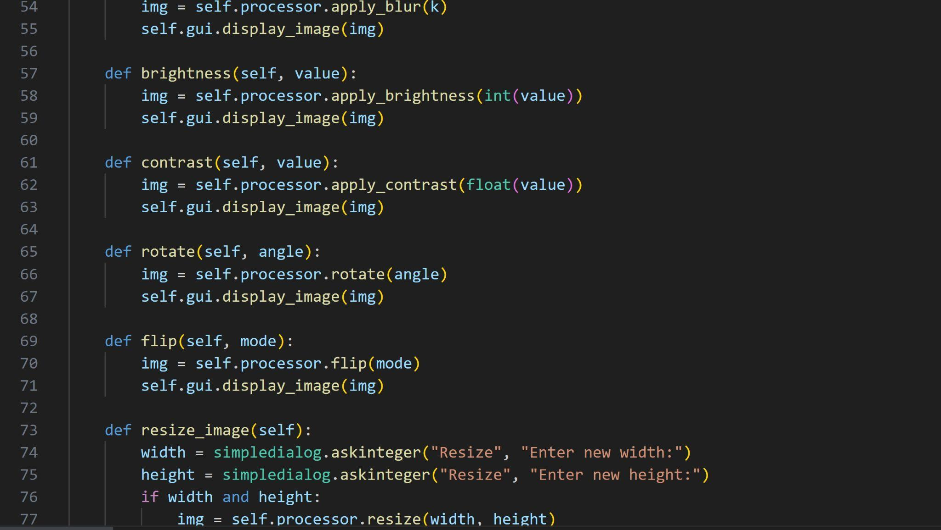

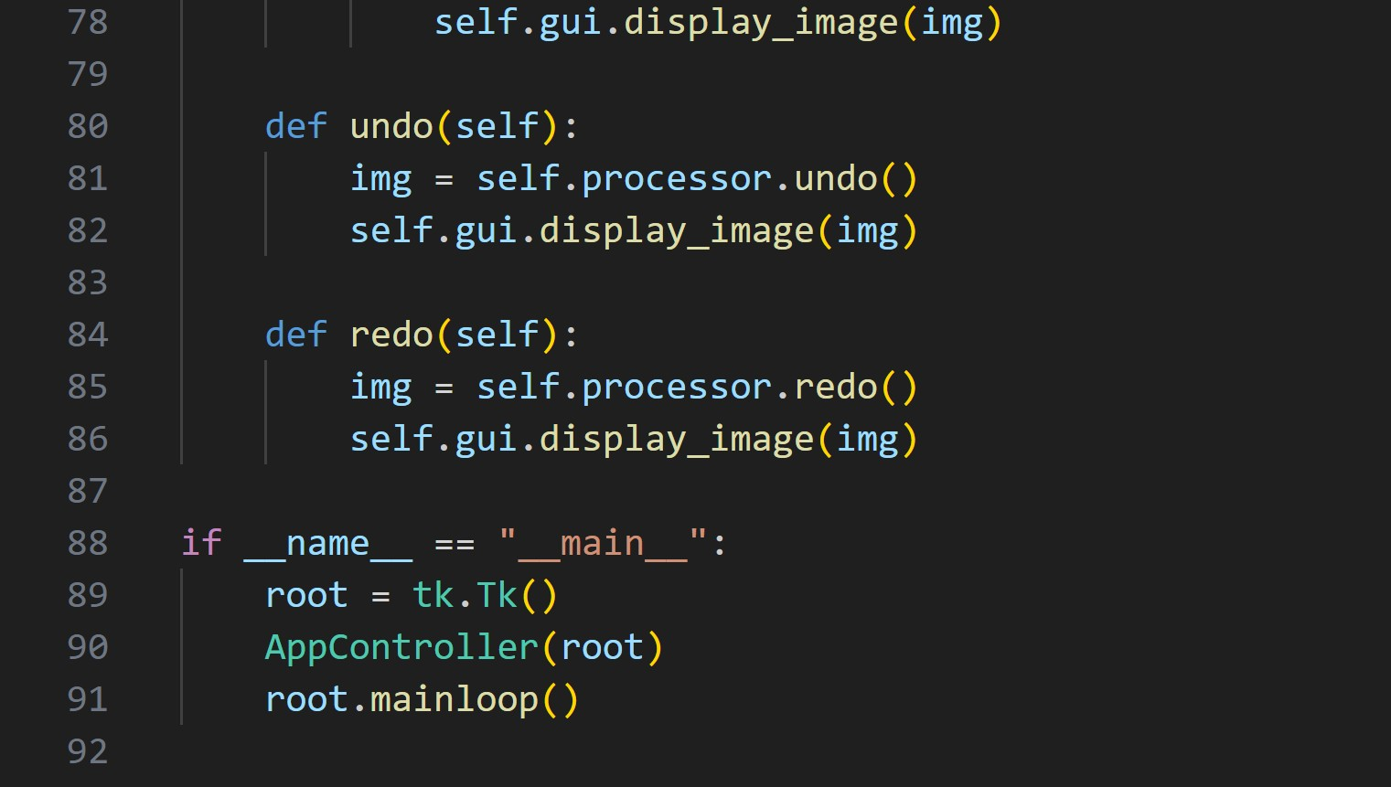

- IMAGE PROCESSING FEATURES

The OpenCV library [1] is used for the image processing tasks. The program can change colored photographs into black-and-white images and use the Canny algorithm to find edges [7]. Gaussian blur can be adjusted to different levels of intensity, through which users can choose how much smoothing is to be done.

The intensity values of pixels are changed while adjusting brightness and contrast to make the images easier to see. The programmer also lets users rotate images, flip them horizontally and change their size based on the specifications they set. Each feature is implemented as a separate method, which makes it sure that the processing is fast and consistent.

Code snippet:
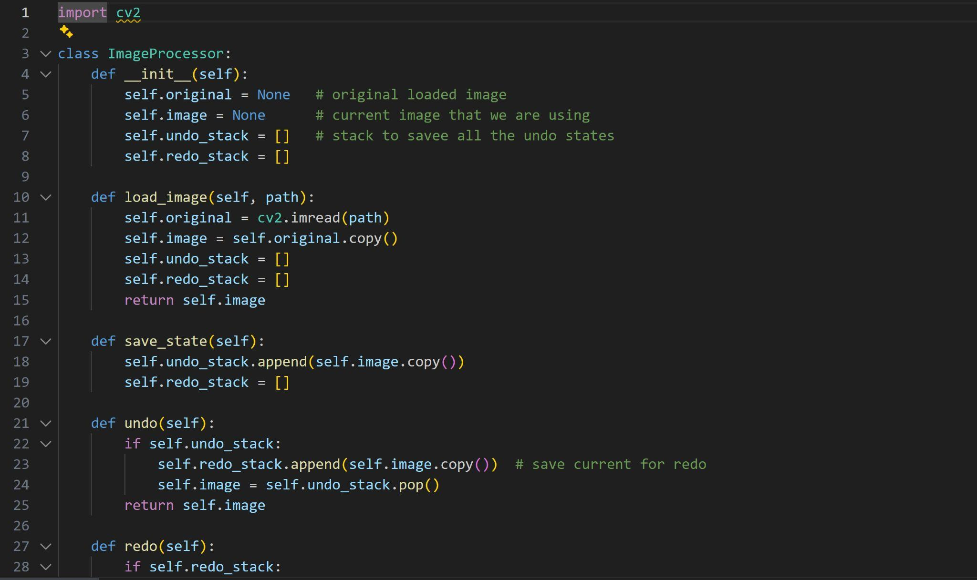
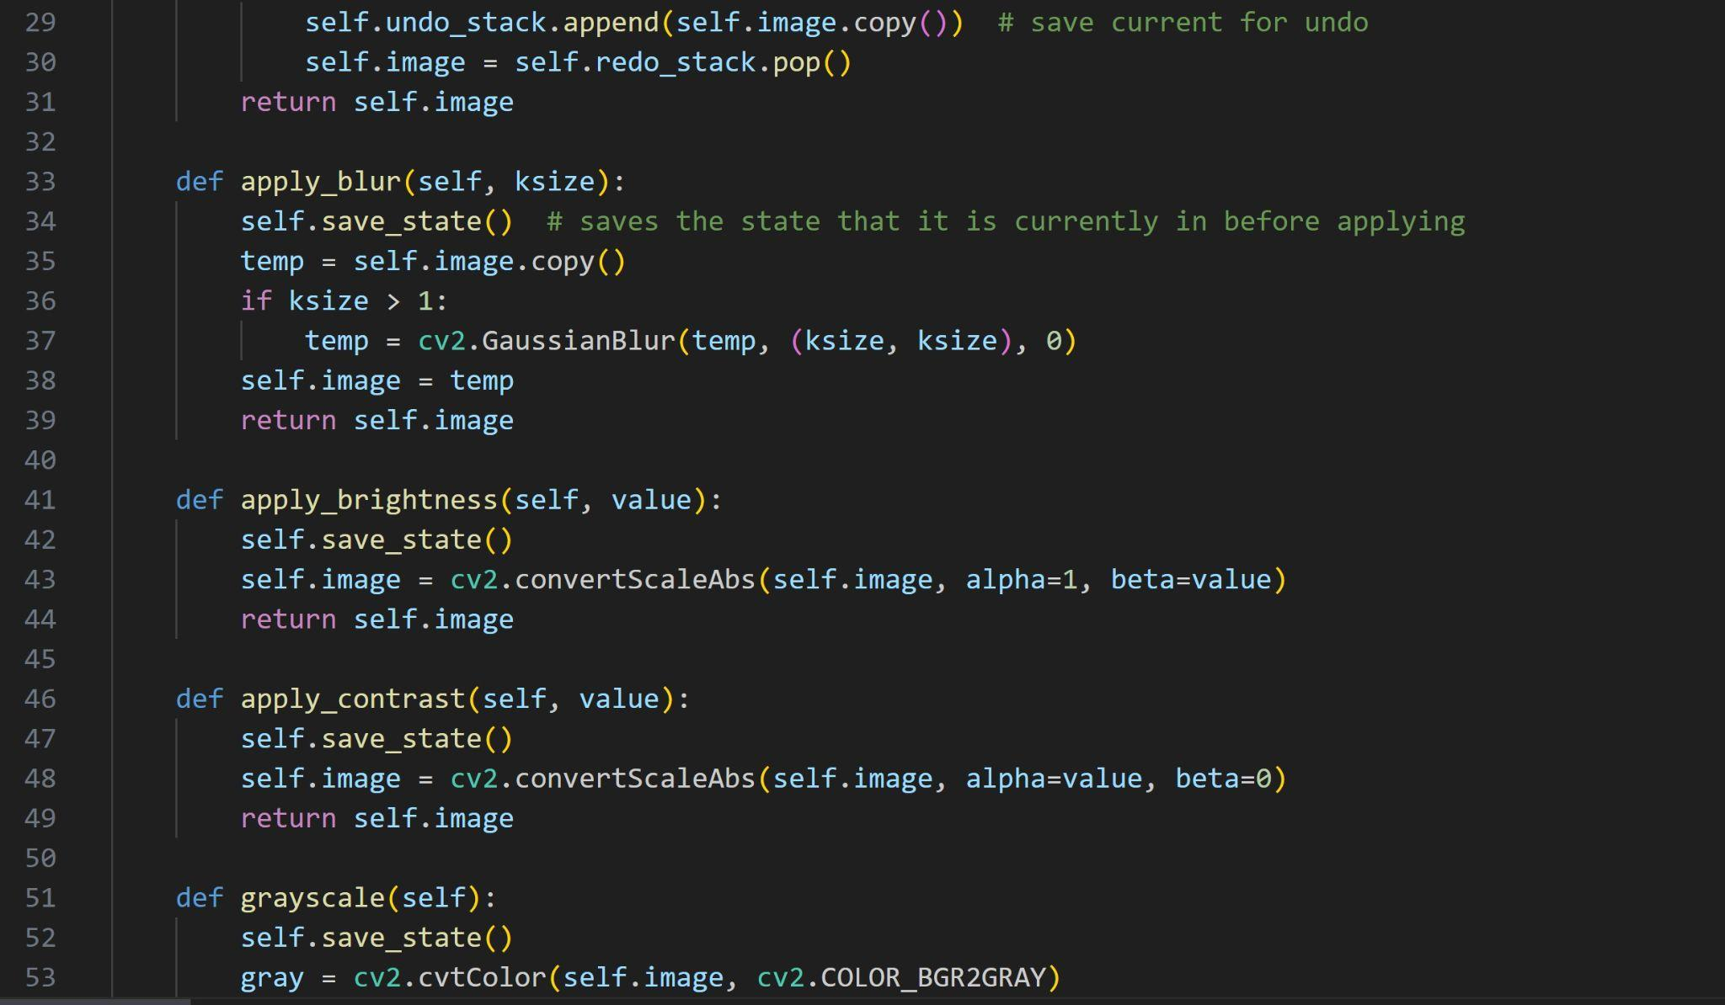
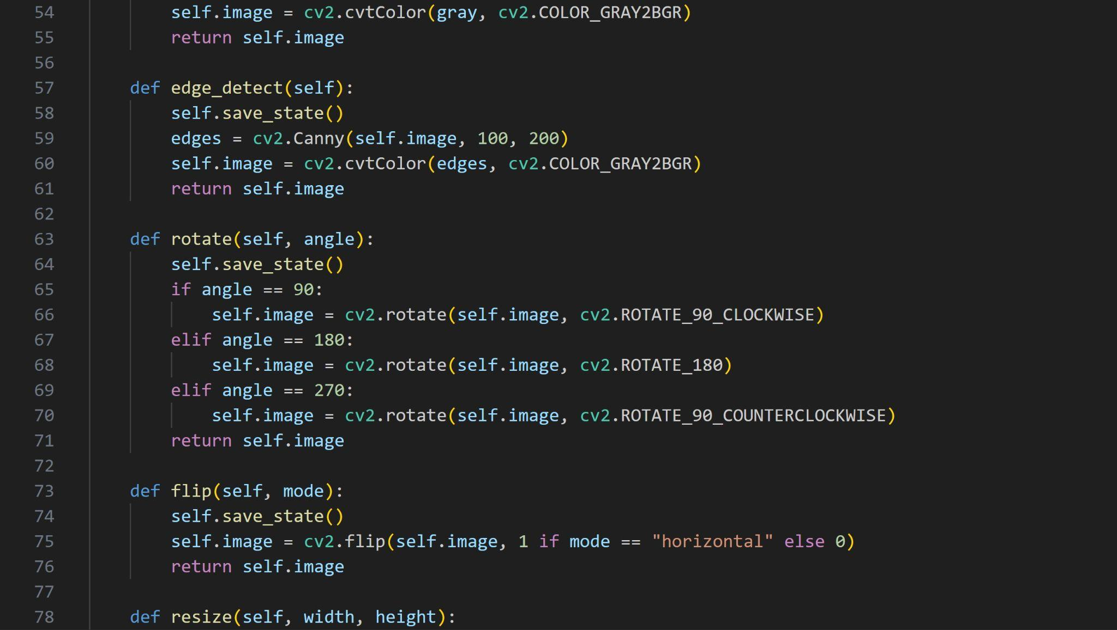
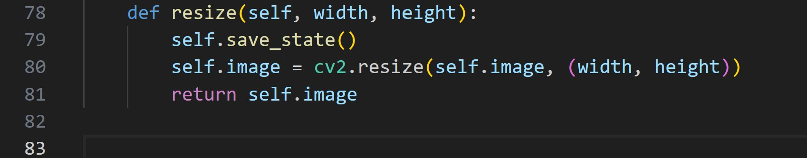

- GRAPHICAL USER INTERFACE DESIGN
The GUI is simple and easy to use and is designed using Tkinter [2]. The menu bar is located in the main window that has actions such as Open, Save, Save As and Exit. There is also an edit menu option that can be used to undo changes. The image display area shows the current image while the control panel has buttons and sliders that can be used to add effects.

The bottom of the window has a status bar that displays information such as the name of the image file and its size. The design of the interface meets all the requirements for the GUI elements listed in the assignment requirements.

Code Snippet:

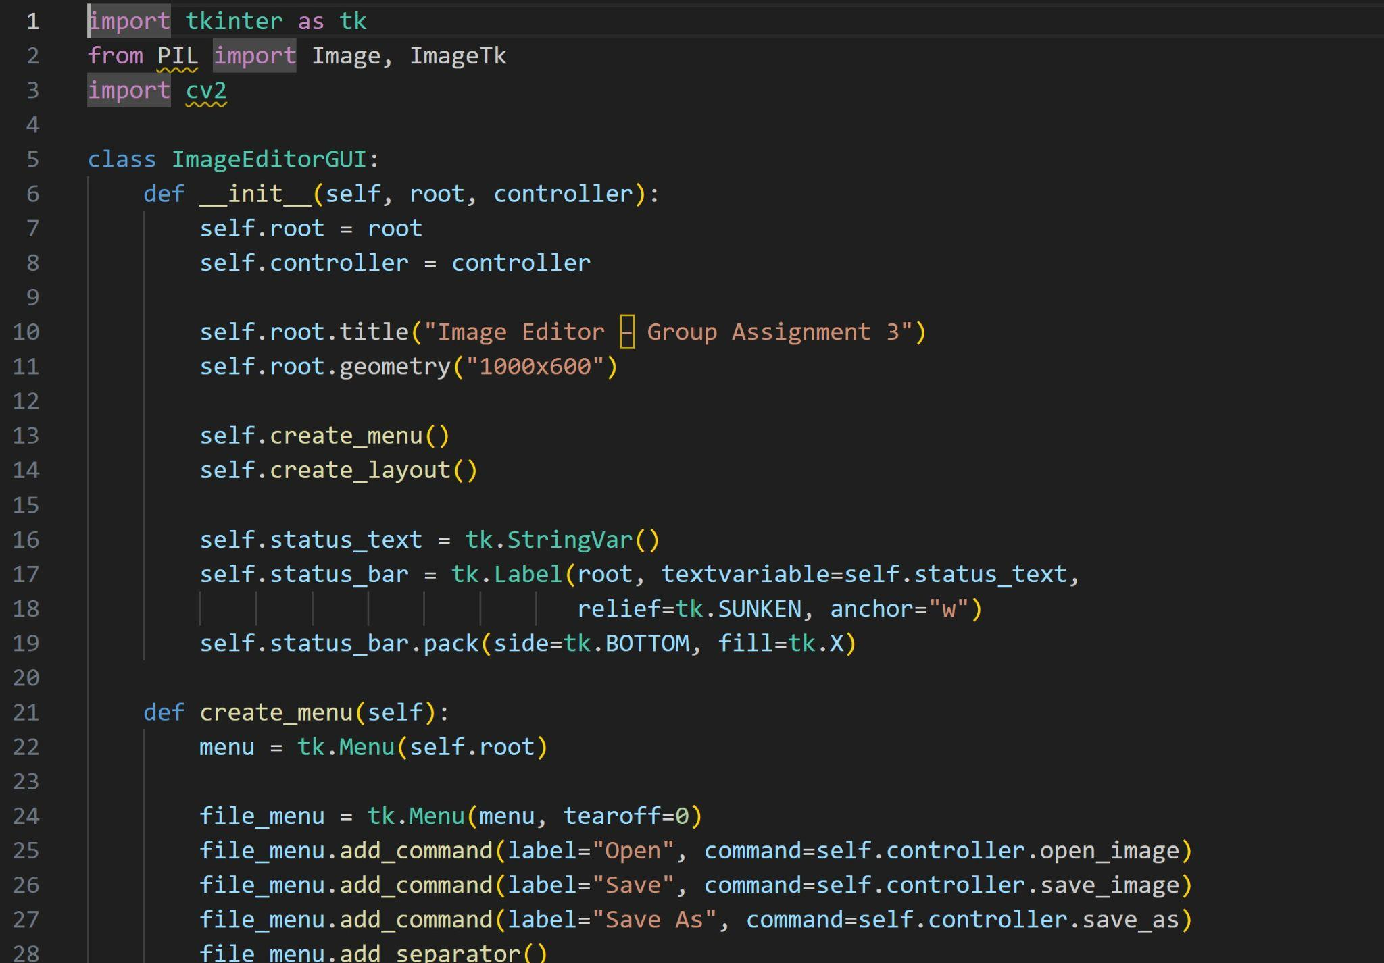
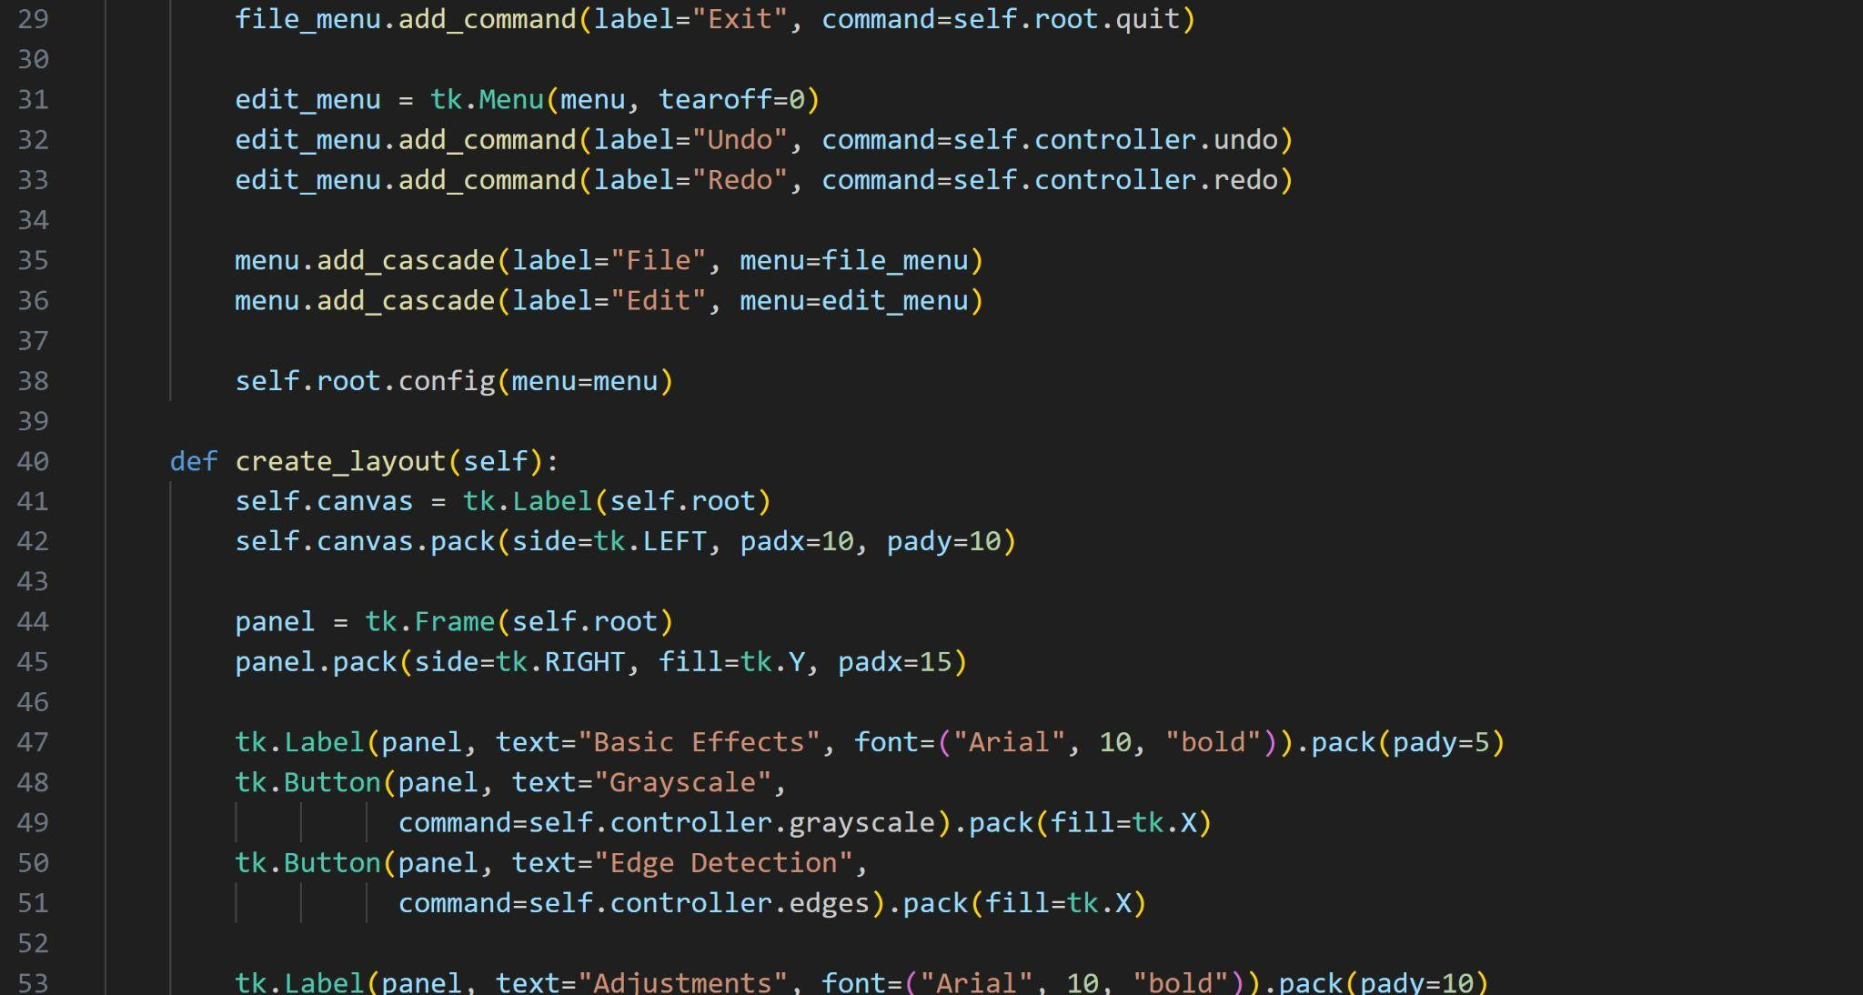

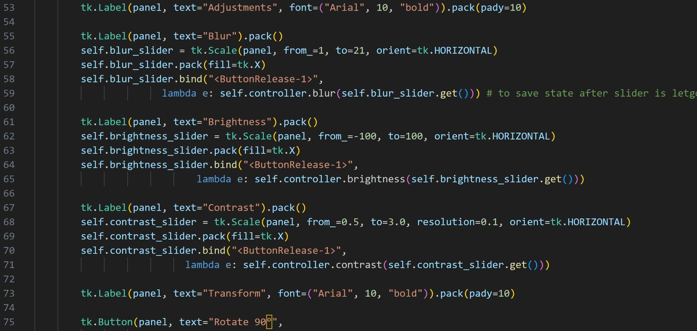
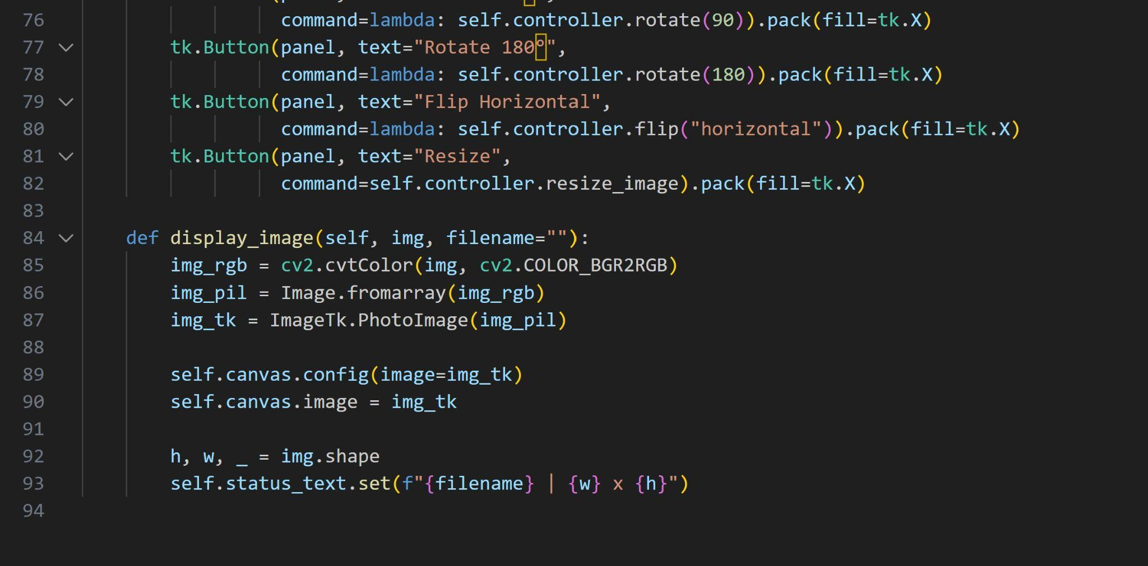

- TEAM COLLABORATION

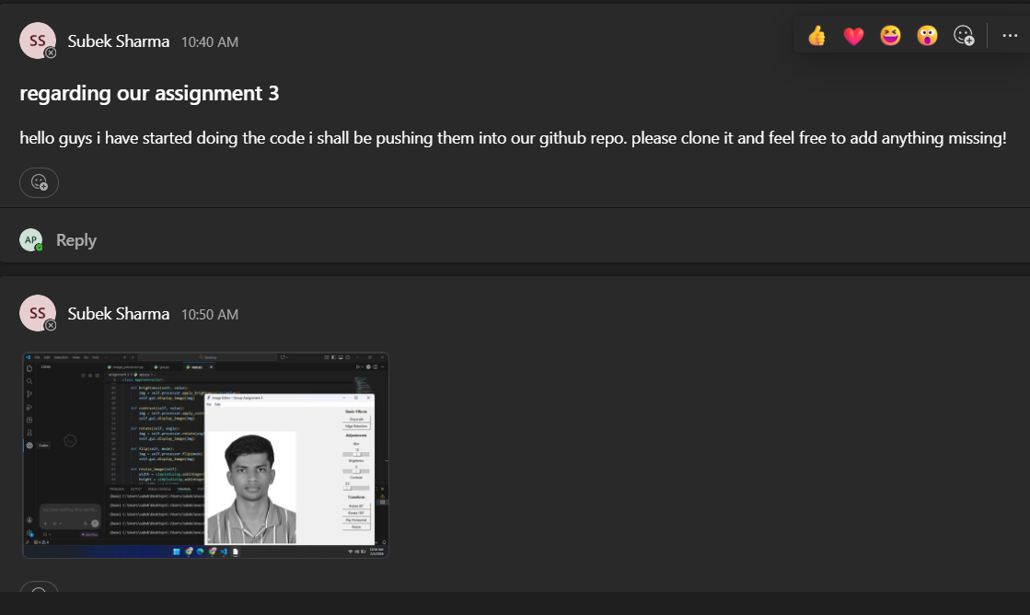

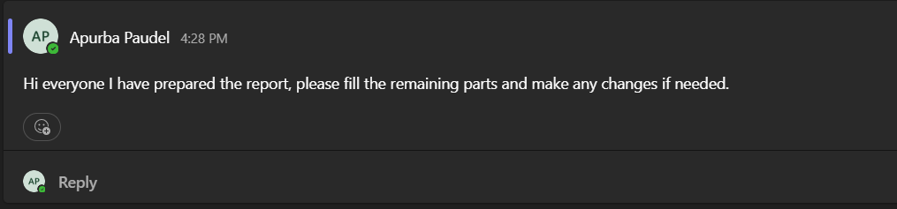

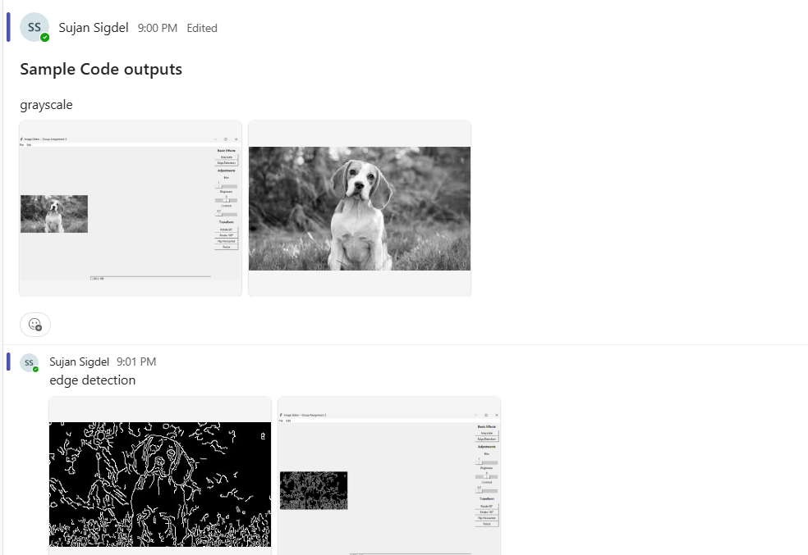
The group worked together to finish the assignment, with each member contributing to different roles. We used the GitHub repository to keep track of different versions and each person’s contribution. Regular communication and working together made sure that our project worked smoothly and was finished on time.

- INDIVIDUAL CONTRIBUTIONS
Apurba (s398926): I was responsible for preparing the final report for this assignment. I analyzed the application, explained the object oriented design and organized the documentation according to the guidelines.

Sujan (s399205): I worked with team members on debugging and improving the application. I helped implement and improve the undo-redo feature, save as feature along with other application features.Overall, I worked collaboratively with my team members throughout the development of the application.

Subek (s398321): On this assignment I primarily worked on writing the code for the application. I wrote the python code using VS code and open cv library for the aforementioned functionalities while implementing the object oriented programming (OOP)concepts. Meanwhile, I also performed black box and white box testing and solved the bugs. Moreover, I also worked on making the desktop application using Tkinter's GUI feature to make the real world use case.

Raksha ( s398446): I worked closely with team members by reviewing and verifying the accuracy of the code along with making sure whether the project requirements are met or not. Additionally, I contributed to report writing by editing sections and checking clarity, alignment with the project requirements and timely completion of the project.

- CONCLUSION
Overall, this assignment gave us the opportunity to have hands-on experience making a whole desktop software with Python. Technical and teamwork skills of the group were developed by using OOP, GUI design and image processing approaches. The project shows how the software design concepts can be used to make an app that works well and is easy to use.

- REFERENCES
[1] OpenCV, “OpenCV: Open Source Computer Vision Library,” OpenCV Documentation. [Online]. Available: https://docs.opencv.org/4.x/
. Accessed: Jan. 2026.

[2] Python Software Foundation, “tkinter — Python interface to Tcl/Tk,” Python 3 Documentation. [Online]. Available: https://docs.python.org/3/library/tkinter.html
. Accessed: Jan. 2026.

[3] Python Software Foundation, “Object-Oriented Programming in Python,” Python Documentation. [Online]. Available: https://docs.python.org/3/tutorial/classes.html
. Accessed: Jan. 2026.

[4] Python Software Foundation, “PIL ImageTk Module,” Pillow Documentation. [Online]. Available: https://pillow.readthedocs.io/en/stable/reference/ImageTk.html
. Accessed: Jan. 2026.

[5] GitHub, “GitHub Documentation: Managing repositories and collaboration,” GitHub Docs. [Online]. Available: https://docs.github.com/en
. Accessed: Jan. 2026.

[6] R. C. Gonzalez and R. E. Woods, Digital Image Processing, 4th ed. New York, NY, USA: Pearson, 2018.

[7] J. Canny, “A Computational Approach to Edge Detection,” IEEE Transactions on Pattern Analysis and Machine Intelligence, vol. 8, no. 6, pp. 679–698, 1986.

